Download:

<https://www.anaconda.com/products/distribution#Downloads>

For mac, pc or linux whatever you have

Open Anaconda Navigator after you have installed it

Click on Environments and then click on create

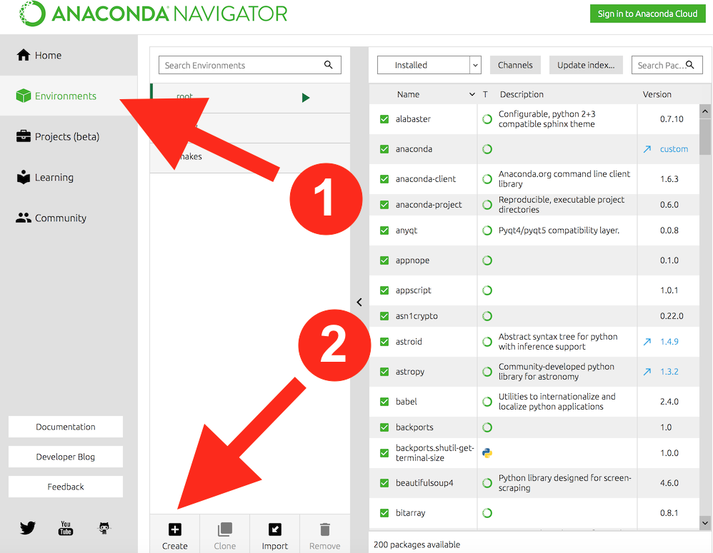

Enter name for your environment and then choose python 3.9.15

Click home and install Jupyter Notebook. Make sure your environment is selected next to Applications on. Whenever you open Anaconda now, you will have an environment under the name you created.

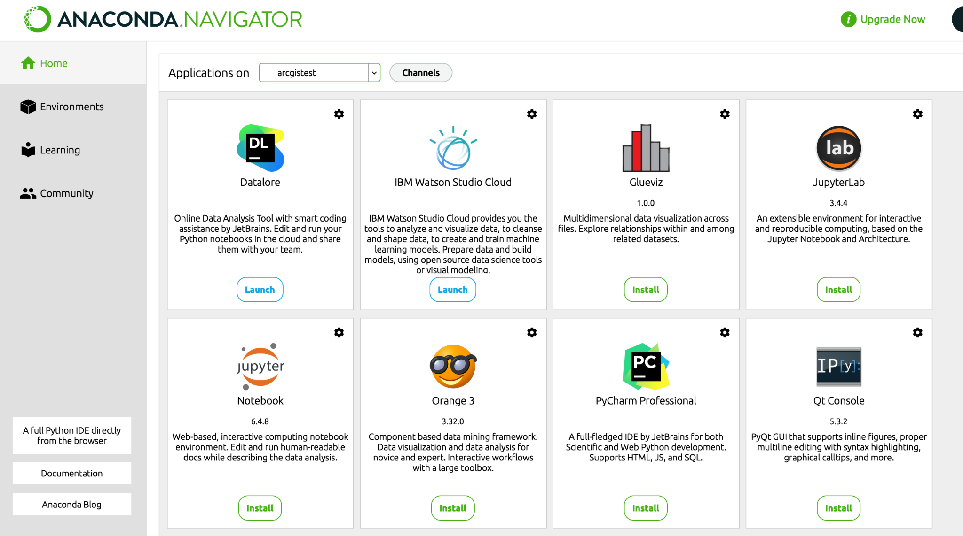

In the future, to navigate to your environment select it in the drop down menu “Application on” at the top of Anaconda.

Navigate to the Environments tab and click the play button next to the environment you just made. Click on Open Terminal.

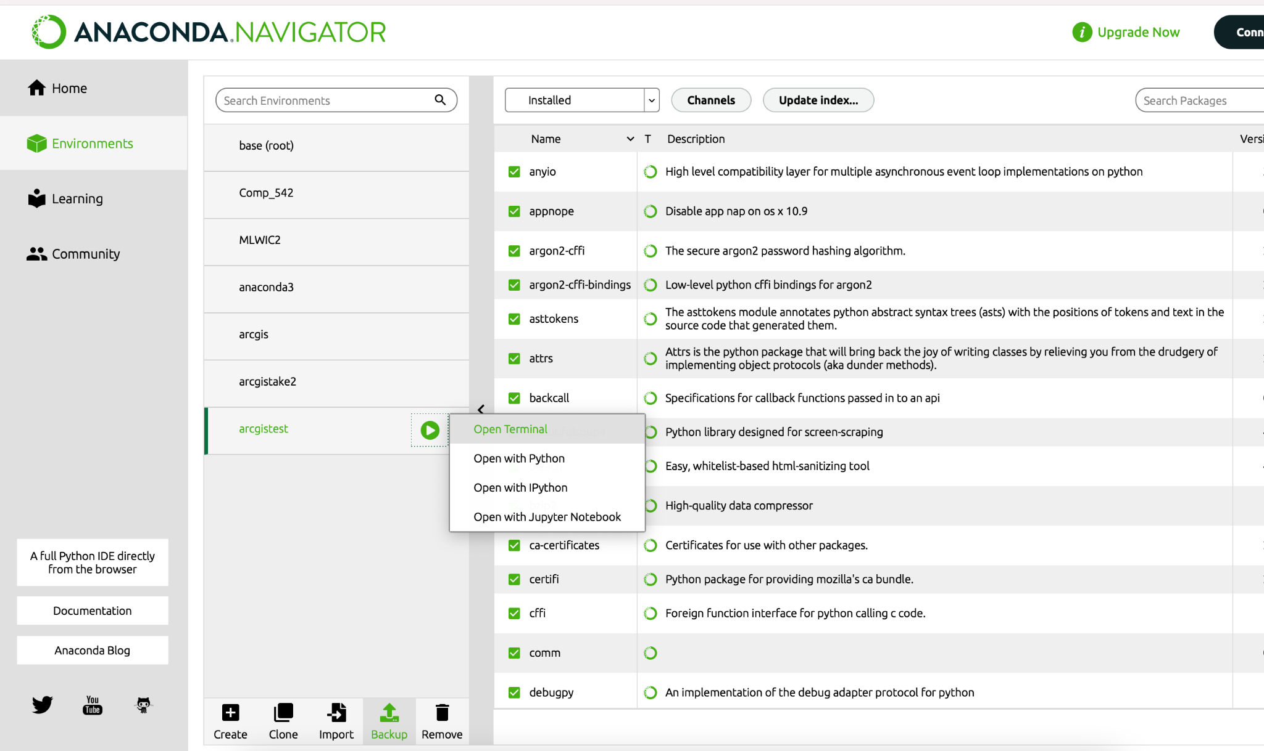

Type this line into the terminal and press enter.

conda install -c esri arcgis

ex//



Successful installation should look like this:

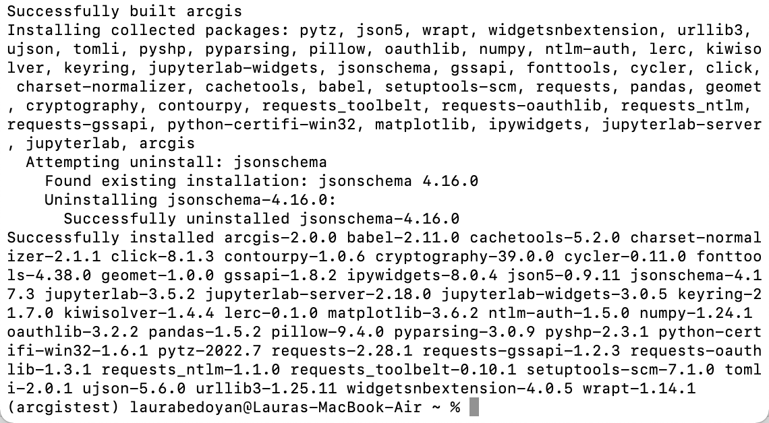

Navigate back to the home tab and click on launch to open jupyter notebook

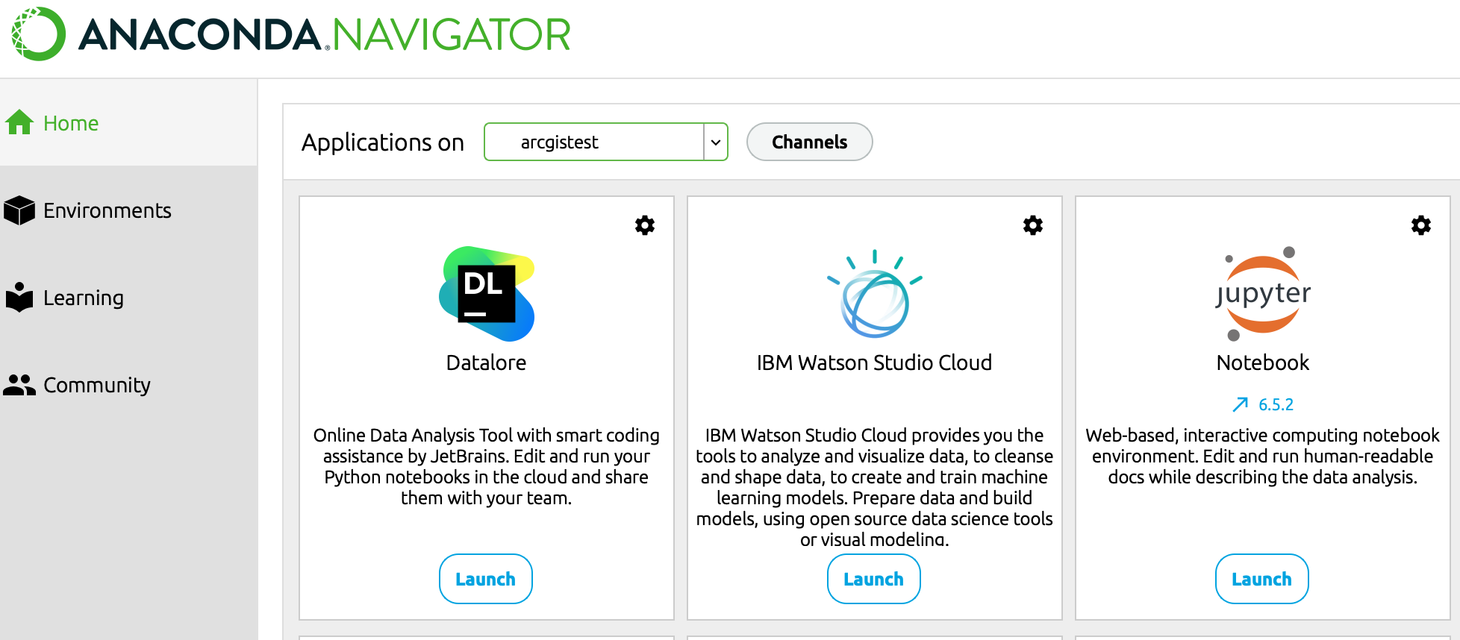

Once Jupyter notebook opens, navigate to the python notebook for this tutorial. It should be titled: Tutorial_ArcGIS.ipynb

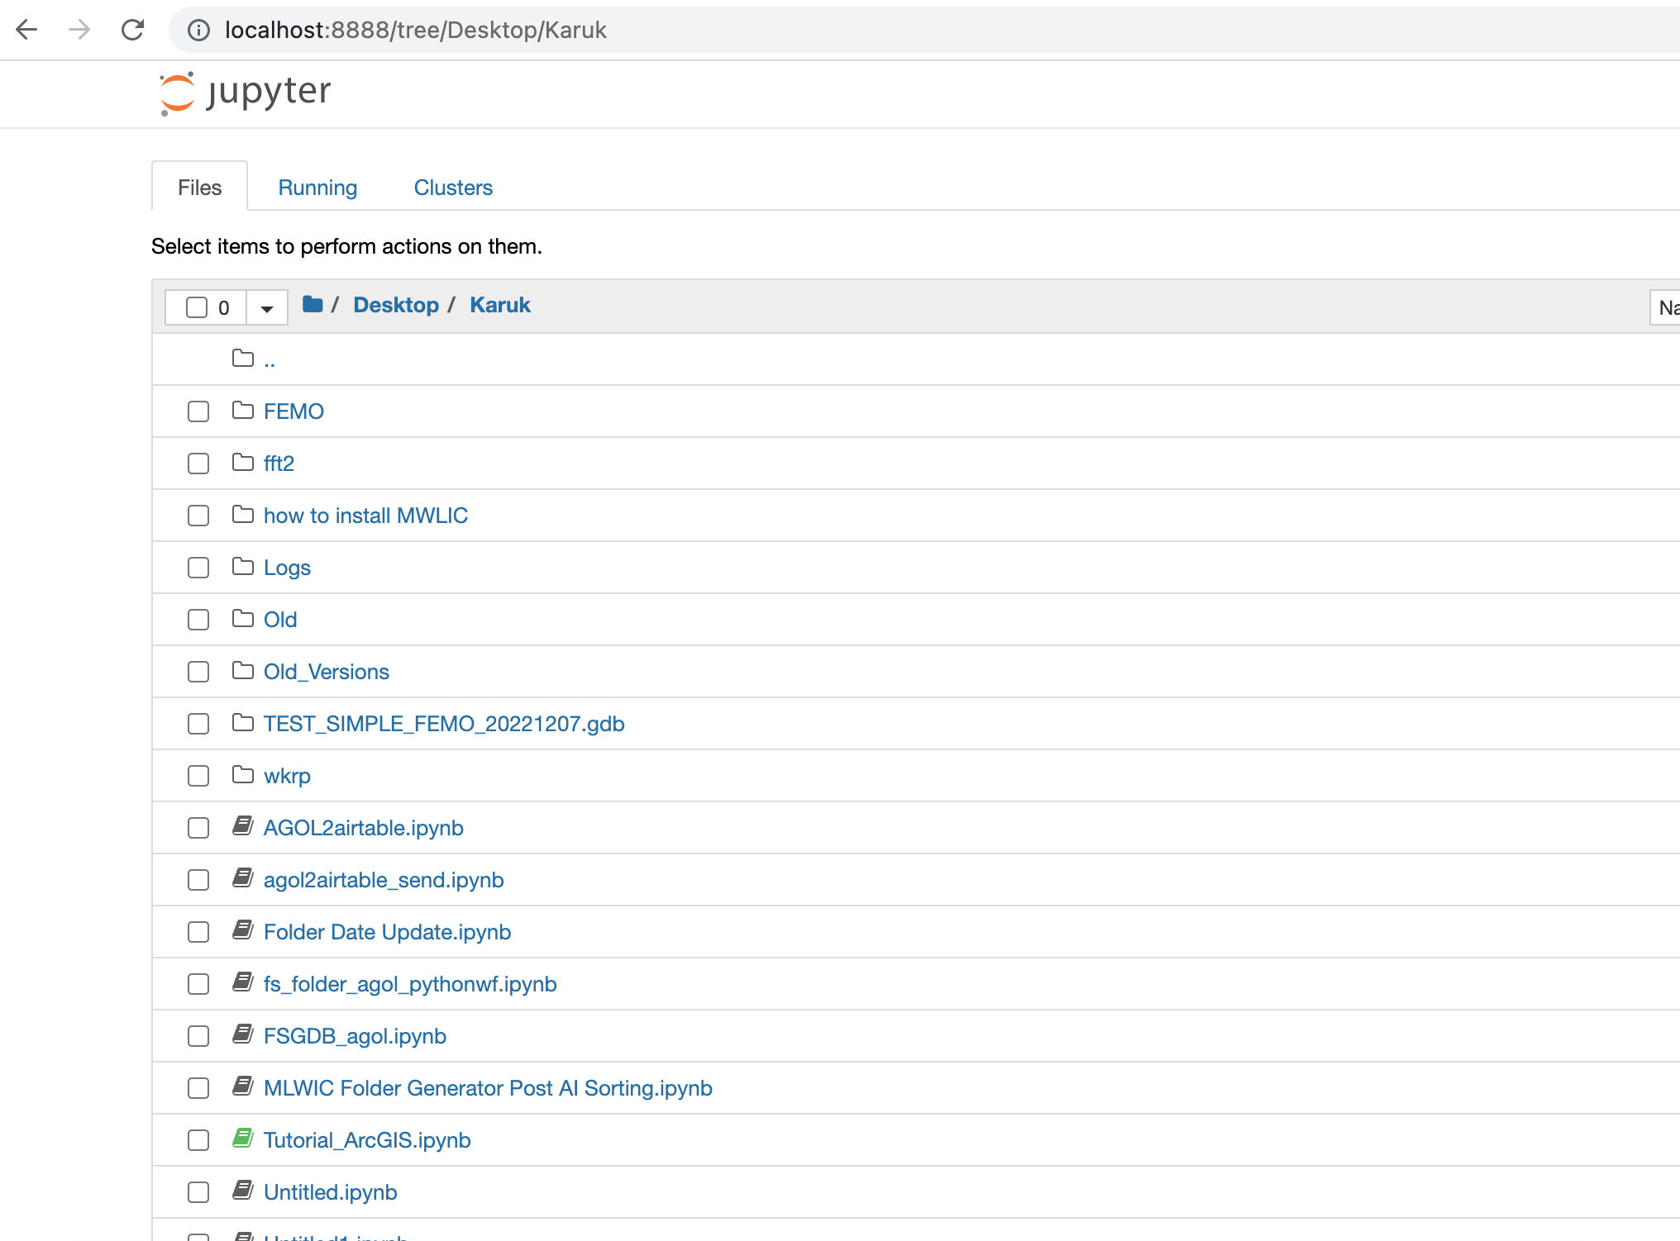

Click once to open

Click on the first box (you will know it is clicked on if it is green/blue) and click run. Do this for each of the boxes

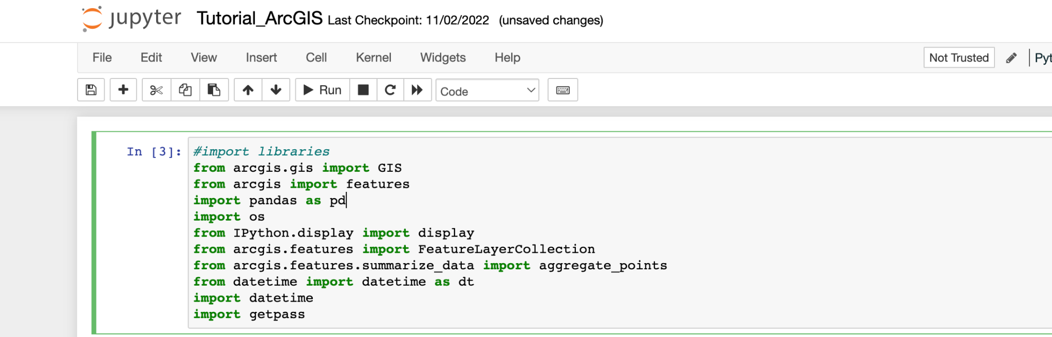

Work through the notebook to see how you can publicly connect to arcgis online.

Follow this tutorial link to see how to get to this step.

<https://youtu.be/rVx1vz4STmU>